**Name : Mohamed Ashraf Hassanein Qaidbay**

**B.N: 662**

**Date : 23/5/2020**

**Topic:** **programming languages**

**Github link :**

**Github page :**

**Application brief :** A *computer programming language* is a [language](https://en.wikipedia.org/wiki/Formal_language) used to write [computer programs](https://en.wikipedia.org/wiki/Computer_program), which involves a [computer](https://en.wikipedia.org/wiki/Computer) performing some kind of computation[[5]](https://en.wikipedia.org/wiki/Programming_language#cite_note-sigplan-5) or [algorithm](https://en.wikipedia.org/wiki/Algorithm) and example, [PostScript](https://en.wikipedia.org/wiki/PostScript) programs are frequently created by another program to control a computer printer or display. More generally, a programming language may describe computation on some, possibly abstract, machine. It is generally accepted that a complete specification for a programming language includes a description, possibly idealized, of a machine or processor for that language.[[7]](https://en.wikipedia.org/wiki/Programming_language#cite_note-nara2-7) In most practical contexts, a programming language involves a computer; consequently, programming languages are usually defined and studied this way.[[8]](https://en.wikipedia.org/wiki/Programming_language#cite_note-8) Programming languages differ from [natural languages](https://en.wikipedia.org/wiki/Natural_language) in that natural languages are only used for interaction between people, while programming languages also allow humans to communicate instructions to machines.

**Screeshots :**

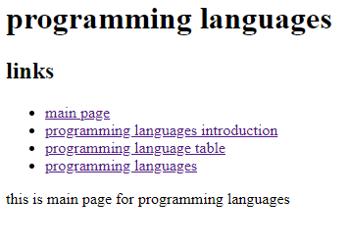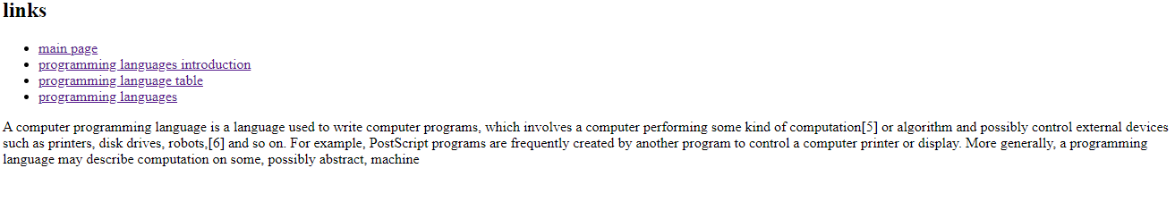

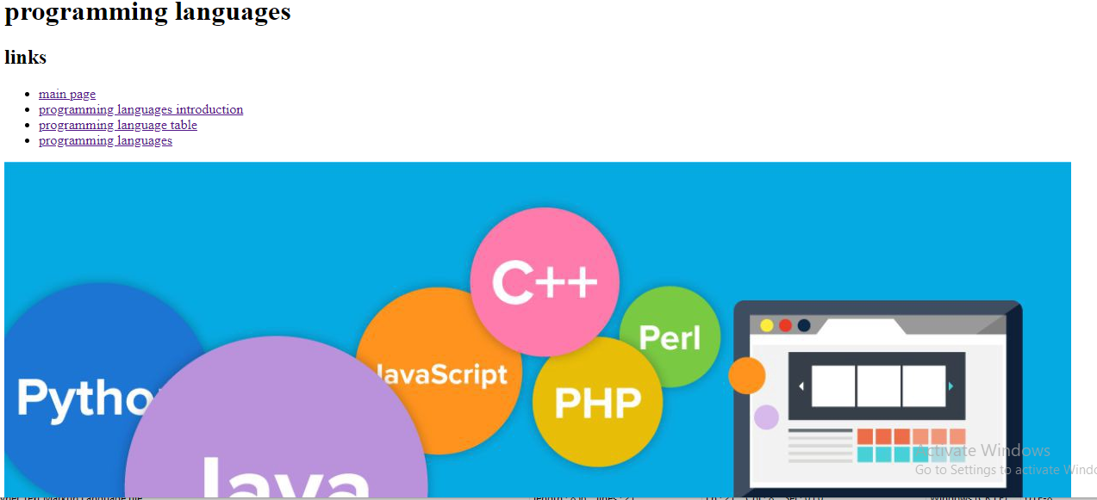

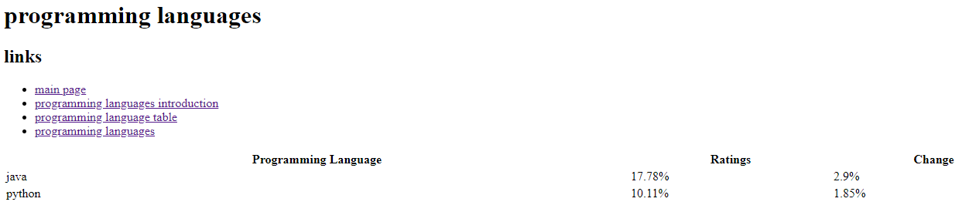

**Source code:**

